MINUTES – 2015 AACA Interim Council Meeting
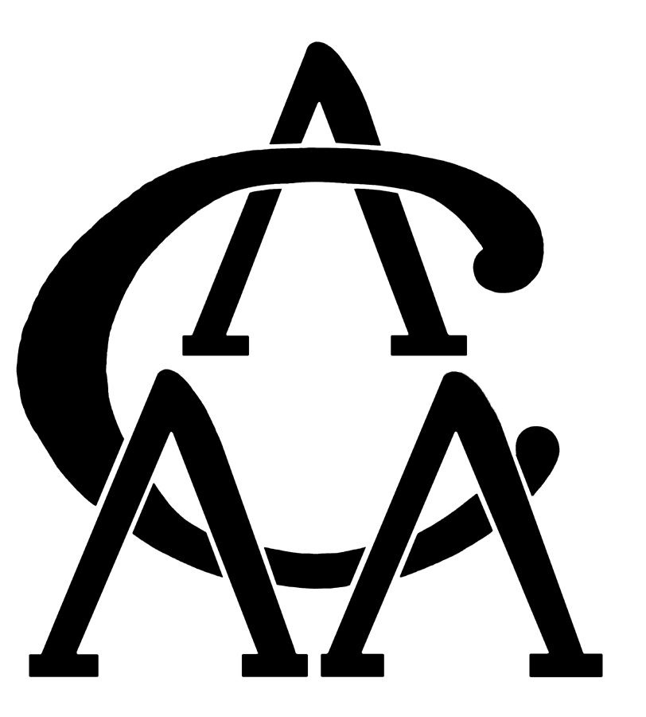
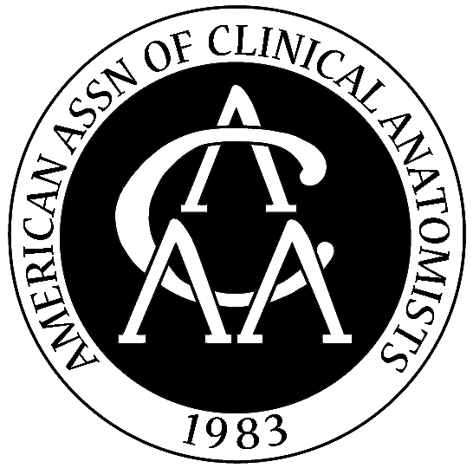

Saturday, October 3, 2015
O’Hare Hilton – Chicago IL
Room 2029

Council Members Present: Anthony D’Antoni, Stephen Carmichael, Alan Detton, Philip Fabrizio, Anne Gilroy, H. Wayne Lambert, Lisa Lee, Carol Lomneth, Marios Loukas, Brian MacPherson, Angela McArthur, Neil Norton, David Porta, Rebecca Pratt, Rob Spinner, Shanan Atkinson (ex officio), and Shane Tubbs (ex officio).

Council Members Absent: None

Guests Present: Jinnie Kim (Wiley Publishing Company)

Breakfast: 8:00 a.m. Central Standard Time (CST)

- CALL TO ORDER - - - - - - - - - - - - - - - - - - - - - - - - - - - - - - - - - - - - - 8:35 a.m.

- APPROVAL OF AGENDA - - - - - - - - - - - - - - - - - - - - - - - - - - - - - - - 8:37 a.m.
The agenda was approved by general consent at 8:37 a.m.

- APPROVAL OF MINUTES - - - - - - - - - - - - - - - - - - - - - - - - - - - - - - 8:37 a.m.
Wayne distributed the minutes to Council from the two recent Council meetings at the 2015 AACA Annual Meeting in Henderson, NV. There was no corrections for these two sets of minutes. The minutes were approved at 8:38 a.m.

- PRESIDENTIAL UPDATE - - - - - - - - - - - - - - - - - - - - - - - - - - - - - -- 8:38 a.m.
Neil brought up four topics that he stated will be addressed throughout the day. These four points were as follows…
  - AACA Policy on Sexual Harassment – After an incident at the Henderson meeting, Neil talked about the importance of instituting a new policy to provide members with a safe environment.
  - Updates from Wiley – Our new representative from Wiley, Jinnie Kim, will be joining our meeting at lunch. Neil noted that the Publishing Agreement will be expiring in a few years, and we need to plan ahead. Neil will be contacting Stuart McDonald of the British Association of Clinical Anatomists (BACA).
  - Somes Guha Proposal and Award – Somes Guha is proposing a new award, and he has been in communication with various members of the Executive Council concerning his willingness to start an annual lecture which will feature a clinician.
  - New award proposal – Stephen Carmichael will be proposing a new award for outstanding anatomists outside North America, and this topic will be discussed during the discussion of the 2016 AACA Awards.

- REPORTS
a. Educational Affairs (EAC) - - - - - - - - - - - - - - - - - - - - - - - - - - - - - - - - - - 8:56 a.m.
Chair's Report (Vaughan Lee)
Composition of Committee: Vaughan Lee (Chair), Erin Fillmore, April Richardson-Hatcher, Peter Ward, Lonnie Salkowski, Elmus Beale

At the EAC breakfast during the 2015 annual meeting, attendees updated the rosters for the sub-interest groups in the areas of: 1) educational technology in anatomy education; 2) educational research methods; 3) post-graduate courses in anatomy; and 4) humanities and anatomy education. EAC is continuing to work with ASG to maintain the listserv for each of these sub-interest groups.

After completion of EAC business, Dr. Adam Fisch (author of Neuroanatomy: Draw It to Know It) spoke about the importance of drawing in anatomy education. Following the talk by Dr. Fisch, attendees were invited to share examples of drawings that they use in their classrooms or laboratory sessions. Many drawings were made on chart paper and displayed for everyone to share.

During the monthly EAC meetings, discussion and planning for the 2016 symposium topic continues. Based on suggestions from the special interest subgroups, a number of topics are being considered. These include, but are not limited to: 1) intellectual property for the creation of digital media; 2) online modules to deliver anatomy content; 3) how much dissection is enough; 4) asynchronous anatomy education; and 5) certification for anatomists. Subsequent EAC monthly meetings will continue to develop and plan for the breakfast meeting and EAC symposium at the 2016 annual meeting.

Due to technical issues and trouble hearing Vaughan on the conference call, Wayne summarized the main points of the EAC report and sent each of the committee reports (that he had received prior to our meeting) to Council members in case these technical issues persisted.

- Clinical Anatomical Terminology (CAT) Committee - - - - - - - - - - - - - - 9:08 a.m.
Chair's Report (Tom Gest)

Composition of Committee: Tom Gest (Co-Chair), Sherry Downie (Co-Chair), O. Paul Gobee, Evan Goldman, John Hansen, Brad Martin, Anthony Olinger, Alan Richards, Rob Spinner (ex officio), Ian Whitmore

The CAT Committee’s report was submitted by Tom Gest, which was composed in collaboration with Sherry Downie. The CAT Committee has met twice since the AACA Annual Meeting to address the business of the committee, once in August and once in September. The following summarizes the activities of the 2015-2016 committee including those meetings conducted in June at the committee meeting in Henderson, NV.

1. CAT Membership/Annual Meeting. At the Annual AACA meeting, John Hansen from SUNY Rochester was appointed and Tom Gest from Texas Tech El Paso was reappointed to the committee by President Neil Norton. Also, Tom was made Co-Chair with Sherry Downie. Evan Goldman from Rowan University was elected by members in attendance at the Clinical Anatomical Terminology meeting.

Committee members discussed scheduling related to the CAT Committee meeting. Any event scheduled on the afternoon of the last day has a significant issue with attendance, which has been a topic of discussion at the MOPP committee for years and is one reason many people have lobbied to hold the banquet on the evening of the last day. One option might be to rotate the day and time of the SIG meetings. We drew no conclusions.

2. FIPAT-CAT Collaboration. The collaboration between members of the FIPAT Informatics group (Pierre Sprumont, Robert Baud, and Paul Neumann), the FIPAT Gross Anatomy group (Tom Gest), and the CAT committee is progressing to develop definitions for anatomical terms in the Terminologia Anatomica and www.Anatomicalterms.info (ATI). Between July and October, 2015 FIPAT and CAT met three times to clarify goals, structure, and process in writing definitions. It is agreed that two types of definitions are needed – “formal” definitions that are compatible with computer programming for Terminologia Anatomica, and “plain language” definitions for ATI.

3. CAT members to review the Committee Rules of Operation. The suggestion has been made that committee members review the Rules of Operation as much has changed since this committee was established.

c. Career Development - - - - - - - - - - - - - - - - - - - - - - - - - - - - - - - - - 9:25 a.m.
Chair's Report (Sarah Greene)

Composition of Committee: Sarah Green (Chair), Yasmin Carter, Alan Detton, Nirusha Lachman, Tony Olinger, Gib Willett

At the 2015 meeting, the CDC was responsible for organizing the judging of student poster and platform awards. This year, judging was completed online by a majority of judges, allowing for much more efficient tabulation of submitted judging forms and determination of award recipients. Awards were presented at the Annual Business Meeting.

During the CDC Breakfast Meeting on Wednesday, June 10, 7:30-9 am, the CDC presented data that was collected from the AACA membership through surveys, followed by a rich discussion of building a portfolio and opportunities for gaining knowledge and experience in clinical anatomy.

The theme for this year’s bi-annual CDC Symposium was Changing Paradigms in Academics. We had an exciting panel of speakers and topics, including Andrew Cawrse, who spoke on the role and influence anatomists have in Hollywood, media, and art; Frank Daly, who addressed how anatomists can be part of the important process for surgical training; and Roy Phitayakorn, who discussed the important relationship between anatomists and surgeons in the clinical teaching arena.

This year’s Mentorship Reception involved a new format from previous years. During the first 30 minutes, Alan Detton presented his thoughts on how to maximize the mentorship process and how that can translate into finding the right career path. At the conclusion of this discussion, all mentees received an access code to an electronic anatomy teaching resource or app that was generously donated. A drawing for prizes, including textbooks and other anatomy resources, followed. After the mentee portion of the reception, mentors were invited to attend to facilitate networking between mentees and mentors.

Since the annual meeting, the CDC has been working to create ways to facilitate communication between mentees and mentors throughout the year. A new Facebook page has been created for this purpose, entitled the “AACA Career Development Connection”, which will be moderated by the CDC, and all members of the AACA will be invited to join and discuss topics to support career growth.

Additionally, the CDC has discussed the addition of a student member for future years. This student member could be either an elected or an appointed member of the committee. This student member of the CDC could also be identified through a selection process. The responsibilities of the student member are continuing to be explored and discussed, but could potentially include a mentored experience with guidance from the CDC.

The CDC would like to thank the outgoing elected members, Jon Wisco, who provided excellent leadership, as well as Dolgor Baatar and Gib Willett for their incredible service the past two years. As well, the CDC would like to thank Caitlin Hyatt and Shanan Atkinson from Association Services Group (ASG) for their assistance, and all members who helped our committee in some manner this year, including and especially our Award judges.

- Brand Promotion and Outreach ad hoc Committee - - - - - - - - - - - - - - - - - 9:49 a.m.
Chair's Report (Jon Wisco)

Composition of Committee: Jon Wisco (Chair), Dolgar Baatar, Ken Jones, Christina Lewis, Danielle Royer, and Peter Ward.

BPOC Activities
We have organized our committee into three subcommittees in accordance with the objectives stated in the Bylaws, and report herein:

Regional Meetings Subcommittee
- Members: Jon Wisco, Ken Jones
- Purpose: Works with Association Services Group to promote and select regional meeting sites

The Regional Meetings Subcommittee has been working with David Morton (University of Utah School of Medicine) to organize and execute the first annual regional meeting. The meeting will be held at the University of Utah School of Dentistry on Saturday, October 17. The theme of the conference is clinical and educational approaches to head and neck anatomy, but posters and breakout sessions can span the breadth of body regions.

Dr. Mark Nielsen (University of Utah) will be speaking on developmental patterns of the head and neck. Dr. Brion Benninger (Western University of Health Sciences) will be speaking on philosophical approaches to head and neck ultrasound. Dr. H. Wayne Lambert (West Virginia University) will be speaking on how to become a stronger candidate for health professions schools and residencies.

The program features 23 accepted presentations, of which, two faculty presenters were asked to convert their e-posters to a combined breakout session on vascular anatomical variations and clinical applications, and one faculty presenter was asked to convert three of his e-posters to a breakout session on osteological anatomical variations and clinical applications. Six breakout sessions, and three meet-the-speaker sessions are scheduled. The remaining presentations were assigned to e-posters, which will be showcased on laptops.

The e-poster format saves space and money for both the student presenters and the society. The format is as follows: 6 slides consisting of 1) Title, 2) Introduction, 3) Methods/Resources, 4) Summary/Description, 5) Conclusions/Significance, 6) Acknowledgements. All presenters will be in the same room during the scheduled time of the conference, but will only need to be present at their e-poster for half of the hour, which will allow them to view other presentations.

To date, 33 individuals have registered from 11 different institutions and four vendors. Ten of the registrants are undergraduate students and two are health professions students.

Logistics of the meeting are being coordinated between the Subcommittee and ASG. As soon as the first annual regional meeting is concluded, the Subcommittee will turn its attention to assisting the group from the University of North Carolina (including Noelle Granger and Kurt Gilliland) in the planning of the second regional meeting.

Community Outreach Subcommittee
- Members: Christina Lewis and Peter Ward
- Purpose: Identifies and establishes collaborations with professional and avocational groups to promote AACA and serve the community.

The Community Outreach Subcommittee has formulated the following objectives:
- To prepare standardized AACA anatomy pamphlets to hand out to interested parties or as the guiding point for educational discussion.
- To organize, engage, and/or participate in anatomy-specific events that will provide an opportunity for AACA to brand itself.

The Subcommittee has identified the following organizations as possible contacts: Mutter Museum (Philadelphia, PA), Bone Clones (Los Angeles, CA), Franklin Institute (Philadelphia, PA), Smithsonian Museums (Washington, DC), and Body Worlds (Germany). In addition, the subcommittee is considering public school outreach through organizations like Anatomy Academy (Jon Wisco). For now, the BPOC has asked the Subcommittee to contact the Mutter museum to inquire the possibility of having a local AACA member provide expertise for tours. The Subcommittee has good connections with the museum and nearby Drexel University to facilitate this initiative (Christina Lewis).

Social Media Subcommittee
- Members: Dolgor Baatar and Danielle Royer
- Purpose: Determines strategies for and implements AACA social media presence

The Social Media Subcommittee has formulated the following objectives:
- To promote AACA to grow the membership base.
- To increase awareness among other organizations and their members (dental and medical education, surgical, orthopedic, osteopathic associations and societies) in order to establish collaboration.
- To facilitate career development of AACA members: enhance networking and improve communication among the members and between members and institutions.
- To facilitate collaborative research.
- For anatomical education (publishing articles, presentations, learning modules, lectures, etc).

The Subcommittee identified two social media avenues that AACA should pursue immediately: Twitter and LinkedIn. AACA already has some presence on Facebook, and the Subcommittee will work with ASG to improve its presence there. Jon mentioned that his committee is proposing to have an official Twitter account for each meeting, and he cited the presence of Lisa Lee and Danielle Royer on Twitter during our recent meeting.

One of the concerns from the Council was the plethora of social media venues and the concern of information overload. It was suggested to focus on one or two social media platforms to project our association’s message and to see where the most interest, among our membership, lies.

- Anatomical Services - - - - - - - - - - - - - - - - - - - - - - - - - - - - - - - - 10:12 a.m.
Chair's Report (Angela McArthur)

Composition of Committee: Angela McArthur (ex officio), Heather Balsiger, Andrew Corson, Todd Hoagland (Academic Co-Chair), Jennifer Mark, Bobbi Morgan, Brandi Schmitt (Technical Co-Chair)

- The Anatomical Services Committee (ASC) has had two conference calls since the AACA Annual Meeting to discuss their annual breakfast meeting in Henderson, to review survey results from the meeting, to select a 2016 symposium and breakfast meeting topic, and to discuss enhancing the ASC web presence.
- In 2015, members of the ASC, due to recent legislative action, conducted a review of laws, rules and regulations which could potentially impact academic body donation programs.
- At the ASC annual breakfast meeting, the committee reviewed their activities from the previous year, presented the finding of their regulatory review, held committee member elections, and presented a “Lessons Learned” session. During this latter session, three presentations were presented, including Angela McArthur (University of Minnesota) discussing the collision between social media and anatomy lab policies, Andrew Corson (University of California, San Francisco) shared practical reasons for electronic storage of donor files, and Todd Hoagland (Medical College of Wisconsin) shared the aftermath of a embalming fluid spill, including how it happened, new risk management procedures, and the positive outcomes that resulted. After this session, a discussion about record keeping practices and document retention requirements occurred.
- Following the Henderson breakfast meeting, the poster session featured several anatomical services related presentations. Because the ASC recently created an award to be given to the best platform or poster presentation at the AACA Annual Meeting specific to scientific studies or case reports in the areas of donor preparation and management, administration of donor programs; and other related areas, the ASC created new judging forms to judge the posters that qualified for this award. Overall, there were 16 submissions for the ASC award but several were disqualified due to subject matter or presenter qualifications. The 2015 award went to Steven Carmichael from the Western University of Health Sciences.
- The ASC also created an appendix form for the purpose of vetting vendors who propose to exhibit human anatomical specimens for purchase during AACA events.
- For the 2016 ASC breakfast meeting, a similar agenda is planned as the 2015 meeting due to the positive feedback of the attendees to this session. The “Lessons Learned” session will focus on the anatomical preparation of human specifics.
- In 2016, the ASC will also hold their symposium at the Annual Meeting. This 90 minute session will focus on donation databases, donor record keeping including document retention, and the tracking of human anatomical donors from acquisition to final disposition.
- In 2016, the ASC will work to: 1) Enhance their web presence; 2) Create a $100 ASC member fee; respond to inquiries and items of topical interest when warranted; and write a viewpoint article to be submitted to Clinical Anatomy on the AACA’s Best Practices for Anatomical Donation Programs document.

After the presentation was complete, discussion ensued concerning the creating a special membership category for technical Anatomical Services members, which would be at a reduced price to regular membership dues. Following this discussion, the following motion was made.

MOTION (Carmichael, Porta): To approve a special membership category with a reduced membership fee for technical Anatomical Sciences members. The motion passed unanimously. The Council charged the Executive Council with the implementation of this motion.

Neil also mentioned the importance of asking the chairs of each committee who are the most active members in each committee, and he uses this knowledge for his Presidential Appointments to the benefit of the committee chairs.

- Membership Committee - - - - - - - - - - - - - - - - - - - - - - - - - - - - - - 10:42 a.m.
Chair's Report (Marios Loukas)

Marios reported that we currently have 804 AACA members (at the end of September). Marios also mentioned the importance of having analytics to keep a better track of specific information concerning membership.

{BREAK 10:47 a.m.}

- MEETINGS - - - - - - - - - - - - - - - - - - - - - - - - - - - - - - - - - - - - - - - - - - 11:00 a.m.
  - Program Secretary/Meeting Organization and Program Planning (MOPP) Committee Chair's Report (David Porta)

David started his report by listing the 25 people included in the MOPP committee conference calls, including the 6 Executive Council members, 7 SIG chairs, 2 Meeting Managers, 6 Annual Meeting hosts for future meetings, 2 hosts of the Utah Regional Meeting, and 2 ASG representatives.

  - 2015 Annual Meeting Report (Porta/Atkinson)
Concerning the Henderson meeting, the AACA had no local host but two meeting managers. David and Shanan performed the site visit in advance of our meeting. He reported that the banquet was almost move to Friday, and we had no postgraduate course. David also reported 164 attendees participated in the Acland Social Event.

Changes that were made for 2015 meeting included:
1) Moving breakfast meeting from 7am to 7:30am
2) Implementation of graduated lunch breaks (including 90, then 75, then 60 minute breaks) to give attendees time to familiarize themselves with the restaurant options in the area.
3) Moving all student platform presentations to the first two sessions to help expedite the judging for student awards
4) Presenting each student platform presenter with a certificate
5) Launching of an application that contained the Annual Meeting Program for attendees
6) Extending poster sessions from 60 minutes to 75 minutes as well as grouping posters by anatomical regions.
David finished his 2015 Annual Meeting Report by reporting some of the meeting statistics post-meeting survey results, and issues that arose during the meeting. Highlights are included:

2015 Annual Meeting Statistics
- Increase in abstract submissions (147) from 2014 (139)
- Increase in abstracts returned to submitter due to formatting errors (51) from 2014 (20)
- Increase in abstract rejections (24) from 2014 (10)
- Decrease in submissions of late breaking abstracts (21) from 2014 (26)
- Increase in meeting registrations (338) from 2014 (327)
- Decrease in platform presentations (22) from 2014 (29), tech fair presentations (3) from 2014 (6), and publishable posters (78) from 2014 (80)
- Increase in the posters NOT published in Clinical Anatomy (43) from 2014 (40)

2015 Annual Meeting Survey Results (76 members & 7 exhibitors responded to the survey)
- Only 23% of survey respondents teach undergraduate students and 2% teach physicians
- 84% stated the meeting met their professional needs (4 or 5 on Likert scale)
- 87% stated they would attend the AACA meeting again
- Concerning the dates of the meeting, only 2 respondents wanted the meeting moved back to July.
- 21 survey respondents used the mobile app; 55 did not use it.
- 62 (of 71) survey respondents want the mobile app to be available for future meetings
- Only one exhibitor had a negative experience, and it was specific to the exorbitant internet cost within the meeting site.
- The rest of the survey results are still being reviewed by the MOPP committee.

2016 Annual Meeting Issues/Suggestions for Improvements
- We need to add a break after the Wiley/Clinical Anatomy luncheon
- We need to improve the IT issues, including the loading times of the presentations
- We need to improve the Awards Presentations
- We have too many poster presenters who are not present at their poster during judging
- We had an issue concerning plagiarism.
- We had an issue concerning a member making unwelcome advances towards another member.

After this part of the presentation, discussion ensued concerning the last issue, which led to a push for adopting a Sexual Harassment policy for the AACA. Neil presented a document that he had prepared in preparation for this discussion. After reviewing the document and making sure it will be included in the 2016 AACA Annual Program, the following motion was made.

MOTION (Carmichael, Gilroy): To approve the Sexual Harassment policy. The motion passed unanimously.

  - 2016 Annual Meeting Committee Report (Porta)

David reported preparation for the 2016 Annual Meeting in Oakland was proceeding on schedule. This meeting is scheduled to occur from June 13-June17 in 2016. The Oakland venue will have two site visitors (Sherry Downie and Greg Smith). He also mentioned that Greg will try to revive the Accompanying Persons Tour. Postgrad course will be Transgender Anatomy, which is being organized by Kim Topp and Sakti Srivastava.

He gave the following timeline for preparations for the Oakland meeting, which including reviewing the abstract submission process in October, opening the abstract submission process in late November, soliciting abstract reviewers in February, setting the abstract submission deadlines for March 9th and March 31st for late breaking abstracts, establishing April 15 as the early bird registration deadline noting that abstract authors must register by April 27.

  - Future AACA Annual Meetings (Porta/Atkinson)
The 2017 AACA Meeting will be in Minneapolis with Tony Weinhaus and Angela McArthur as local hosts.
The 2018 AACA Meeting will be in Atlanta with Larry Wineski serving as the local host.
The 2019 AACA Meeting may be in Tulsa with Elmus Beale serving as the local host.
For the 2020 AACA Meeting, we are hoping for a joint meeting with the British Association of Clinical Anatomists (BACA), which may occur in Charlotte or abroad
The 2021 AACA Meeting may be in Ft. Worth with Rusty Reeves serving as the local host,
The 2022 AACA Meeting may occur in San Antonio with Chris Walters serving as the local host.

WORKING LUNCH - - - - - - - - - - - - - - - - - - - - - - - - - - - - - - - - - - - - - - - - - - - - 12:00 p.m.

- JOURNAL COMMITTEE (Loukas/Tubbs) - - - - - - - - - -- - - - - - - - - - - 12:10 p.m.
Impact factor is 1.332 a 15% increase. Shane covered topics of future special issues, including superficial landmarks, common chromosomal abnormalities, evidence based anatomy, anatomy education in the new millennium, paleobiology, cardiac anatomy, and ethics in anatomy. Clinical Anatomy app is now available, and current papers of interest were discussed. The Council was also introduced to Jinnie Kim, our new Wiley representative. Shane also announced his new position in Seattle.

- POSITIONS FOR 2015 ELECTION (Lambert/Norton) - - - - - - - - - - - - 1:00 p.m.
Wayne stated that Greg Smith was appointed to Chair the AACA Nomination Committee. For the 2016 AACA Election, the following 4 positions will need to be filled on Council.
AACA Treasurer
Special Clinical Councilor
2 Councilors-at-Large positions

- AWARDS (Lambert/Norton) - - - - - - - - - - - - - - - - - - - - - - - - - - - - 1:05 p.m.
- Honored Member Award – After presenting each candidate, Dr. Carlos Machado was selected by Council for the 2016 Honored Member Award.
- R. Benton Adkins, Jr. Distinguished Service Award - After presenting each candidate, Dr. Tom Quinn was selected by Council for the 2016 Benton Adkins, Jr. Distinguished Service Award.
- Somes Guha Award Proposals – The Council discussed Dr. Guha’s proposals, and much of the discussion centered on donating to have naming rights (or other strings). Members of Council felt strongly that we need to put price tags on such sponsorships and have donors reach a certain level if they to name an award. The dollar amount for Dr. Guha’s proposal was felt to be too small for naming rights (and the money is not endowed). For example, if Member A gives $1,000 and Dr. Guha gave $600 for an award. The $1,000 sponsor (Member A) may feel slighted as to why they do not have an award named after themselves when providing a larger monetary donation. Furth discussion regarding the Lectureship centered on Council not feeling that there was adequate time in the program to keep adding Lectureships every time a donor wanted to offer a donation exceeding $1,000. The question was when we stop, and that, in the future, we should set a benchmark for future donors seeking naming rights for an award or lecture.
- Proposal of New Award (Carmichael) – After deliberation concerning having an international award for outstanding clinical anatomists, talk focused on establishing a lectureship in which these individuals can attend the meeting.

MOTION (Carmichael, Porta): To create an international lectureship to invite a top anatomist to speak at our annual meeting, when an appropriate candidate is identified. The motion passed by majority.

- ASG REPORT (Atkinson) - - - - - - - - - - - - - - - - - - - - - - - - - - - - - - - - - 1:36 p.m.
Shanan reported that the ASG has been submitting their billing hours monthly to Carol. She stated that the ASG are responsive to any request, so let Caitlin and/or Shanan know how they can improve in the future.

- TREASURER’S REPORT - - - - - - - - - - - - - - - - - - - - - - - - - - - - - - - - 1:40 p.m.
Treasurer's & Committee Chair's Report (Carol Lomneth)

Carol reviewed the financial standing of the AACA. While showing the Council members the major meeting expenditures from our 2013-2015 AACA Annual Meetings, Carol reported the 2015 Henderson meeting led to an AACA profit of $38,589, after $168,957 in income and $130,368 in expenses. This AACA profit of $38,589 is a record profit when compared to our past annual meetings ($35,780 in Orlando in 2014; $6,437 in Denver in 2013; $10,344 in St. Georges in 2012). The AACA has a current bank balance (on August 31, 2015) of $179,866, and she reported a profit of $353,478 and expenses of $284,976 for a net gain of $68,502 in 2015. Carol listed the royalties derived from the Clinical Anatomy journal as $74,910 in 2015, which is an increase of $7,648 from the previous year (2014). She also listed the breakdown in expenses and hours worked by ASG. While Carol has been working to grow our savings to support a one year operating budget (~$300,000), she mentioned that she is happy that our financial well-being is still heading in a positive direction. At the conclusion of her presentation, Neil thanked Carol for her work as the AACA Treasurer.

{BREAK 2:03 p.m.}

- OLD BUSINESS - - - - - - - - - - - - - - - - - - - - - - - - - - - - - - - - - - - - - - - 2:18 p.m.
Brief update from ad hoc AACA Committees

a. ad hoc AACA Legacy Committee - - - - - - - - - - - - - - - - - - - - - - - - - - 2:18 p.m.
(Anne Gilroy)

Anne mentioned the importance of emphasizing the history of the AACA to our young members. Discussion centered on ways to highlight our Honored Members and people who significantly impacted our professional association. One suggestion was to produce posters, similar to the historical posters constructed by Peter Abrahams, to emphasize our history.

b. ad hoc Committee for CME - - - - - - - - - - - - - - - - - - - - - - -- - - - - 2:31 p.m.
(Marios Loukas)

Marios has been working with his legal department at St. George’s University in Grenada to discern if the AACA could be an accredited body who can offer CME credits in any state. He mentioned we could also go through Wiley to get CME credits for reviewing papers. Discussion also went back to the competencies for anatomy teachers. Marios would like to have different working groups to figure out competencies on different regions of the body.

c. ad hoc Sponsorship Committee (vendor/member) - - - - - - - - - - - - - 2:59 p.m.
(Atkinson)

Shanan mentioned $10,870 was collected from members to help fund student awards.
Neil mentioned that he would like to see donations go into the coffers for the good of the AACA. However, Rob Spinner mentioned that you shouldn’t define donations by any numerical amount, and he suggested that we need to put price tags on sponsorship and make donors reach a certain level before the granting of an honorary title. Discussion led to the following motion.

MOTION (Porta, Lee): To encourage donors to give to the general sponsorship fund without creating additional “named” awards, but still create a level where endowed scholarships named for individuals could occur. The motion passed unanimously. Following the voting for this motion, Neil asked Brian to chair the ad hoc Endowment Committee and to examine the feasibility of creating an endowment.

LISTSERV (Norton/Lambert) - - - - - - - - - - - - - - - - - - - - - - - - - - - - - - 3:33 p.m.
Neil and Brian talked about the importance of transitioning the Listserv from Albert Einstein to the Google platform (Google Drive) that Caitlyn has found will be effective for the AACA. A clean break on January 1, 2016 was proposed.

- NEW BUSINESS - - - - - - - - - - - - - - - - - - - - - - - - - - - - - - - - - - - - - - -{3:39 p.m.}
None

ADJOURNMENT: 3:40 p.m.

Respectfully submitted,
H. Wayne Lambert
AACA Secretary

